**SMART PUBLIC RESTROOM**

**TEAM MEMBER**

6226211210:

**Phase 5 Submission Document**

**Project Title:** **Smart Public Restroom**

**Phase 5:** **Project Documentation & Submission**

**Topic:** ***Complete Project document of Smart Public Restroom using IOT.***

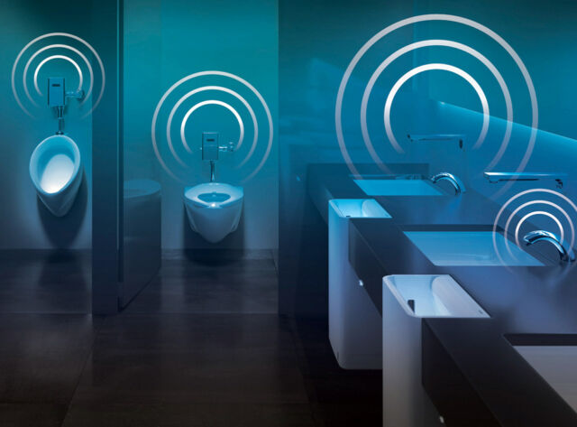

Smart Public Restroom using IOT

**Smart Public Restroom**

**Introduction:**

* In an era of rapid technological advancement, the concept of a "smart" public restroom, empowered by the Internet of Things (IOT), has emerged as a shining example of innovation at its finest. Gone are the days of conventional, static restrooms that merely serve a functional purpose. Today, these essential facilities have been transformed into dynamic, interconnected spaces that prioritize hygiene, user convenience, resource efficiency, and sustainability. The integration of IOT technology has ushered in a new era where public restrooms are not just clean and well-maintained but are also equipped with a range of cutting-edge features that enhance the user experience and make management more efficient than ever. This introduction explores the transformative impact of IOT on smart public restrooms, showcasing how technology is revolutionizing our most fundamental and essential spaces.
* Public restrooms are an essential part of modern urban infrastructure, serving the basic human need for sanitation and hygiene. However, these facilities have historically faced challenges related to maintenance, hygiene, and user experience. In recent years, the integration of Internet of Things (IOT) technology has transformed traditional public restrooms into "smart" spaces that offer an array of benefits to both users and facility managers.
* A smart public restroom, powered by IOT technology, is designed to enhance overall functionality, efficiency, and user satisfaction. It leverages a network of connected sensors, devices, and data analytics to provide real-time insights and automation, thereby revolutionizing the way public restrooms are managed and experienced.
* In essence, the integration of IOT technology into public restrooms marks a significant shift towards more efficient, user-friendly, and hygienic facilities. These smart public restrooms not only improve the quality of life for the general public but also reduce operational costs and environmental impact, making them an essential part of the smart cities of the future. This comprehensive approach to restroom management demonstrates the potential of IOT in enhancing everyday experiences and underscores its significance in urban infrastructure development.

**Given data set:**

|  |  |  |  |  |  |  |  |  |  |  |
| --- | --- | --- | --- | --- | --- | --- | --- | --- | --- | --- |
| Date and time | Toilet ID | Occupancy | Temperature | Humidity | Air quality | Water flow | Paper level | Soap level | Trash level | Other sensors |
| Date and time | 1 | Occupied | 25°C | 50% | Good | 1 L/min | 75% | 50% | 75% | None |
| Date and time | 2 | Unoccupied | 26°C | 55% | Good | 0 L/min | 100% | 100% | 50% | Motion sensor |
| Date and time | 3 | Occupied | 27°C | 60% | Fair | 2 L/min | 50% | 25% | 100% | None |
| Date and time | 4 | Unoccupied | 28°C | 65% | Poor | 0 L/min | 25% | 0% | 100% | CO2 sensor |

**Here’s a list of tools and software commonly used in the process:**

Creating a smart public restroom using IOT (Internet of Things) involves a combination of hardware and software tools to monitor, manage, and enhance the restroom's functionality. Here's a list of common tools and software used in the process:

1. IOT Sensors:

- Motion sensors: Detect the presence of users to trigger actions like flushing toilets, turning on lights, or dispensing soap and water.

- Proximity sensors: Measure the proximity of users for touch less operation of fixtures.

- Ultrasonic sensors: Monitor water levels in urinals and toilets for efficient maintenance.

2. Smart Fixtures:

- IOT-enabled toilets, urinals, and sinks: Equipped with sensors to monitor usage and control water flow.

- Smart soap dispensers: Dispense soap automatically and can be monitored for refill status.

- Smart paper towel dispensers: Dispense paper towels when needed and report refill requirements.

3. Connectivity:

- IOT communication protocols: MQTT, Co-AP, HTTP, or Web Socket to connect sensors and devices to a central system or cloud platform.

- Wi-Fi or Bluetooth connectivity: To enable communication between devices and the central management system.

4. Central Management Software:

- IOT platform: A cloud-based IOT platform to manage and monitor all restroom devices and sensors in real-time.

- Dashboard and analytics: A user-friendly interface for administrators to access data and analytics, manage resources, and set automation rules.

5. Security and Access Control:

- Access control systems: IOT-enabled door locks, RFID card readers, or biometric access control for secure entry.

- Surveillance cameras: IOT cameras for security monitoring and to ensure cleanliness.

6. Energy Management:

- Smart lighting: IOT-controlled lighting that adjusts based on occupancy and natural light.

- HVAC control: IOT systems to manage temperature and ventilation based on occupancy and usage.

7. Water Management:

- IOT-enabled water meters: Monitor water usage for sustainability and maintenance purposes.

- Leak detection sensors: Notify of any water leaks or issues.

8. Maintenance and Service Management:

- Predictive maintenance software: Analyses sensor data to predict when fixtures or devices need servicing or replacement.

- Service ticketing systems: To create, track, and manage maintenance requests.

9. Mobile Apps:

- User-friendly mobile apps for restroom visitors to locate and access nearby smart public restrooms.

- Feedback and rating systems for users to report issues or provide feedback.

10. Integration with Public Services:

- Integration with local municipalities and service providers to ensure cleanliness, accessibility, and availability of public restrooms.

11. Remote Control:

- Ability to remotely control and manage devices and fixtures for maintenance or troubleshooting.

12. Voice Assistants (optional):

- Integration of voice-controlled systems for a touch less and convenient restroom experience.

13. Data Analytics:

- Analytics Tools: Utilize tools like Apache Spark, or specific IOT analytics platforms to gain insights from sensor data.

- Data Visualization: Tools like Tableau, Power BI, or custom dashboards for real-time data visualization.

14. Web Development:

- Custom web portals for remote monitoring and control of smart restroom facilities.

- Front-end and back-end web development frameworks and languages.

15. Firmware and Software Development:

- Embedded software for IOT devices and actuators.

- Firmware up-date mechanisms for over-the-air updates (OTA).

16. Data Storage:

- Databases like Mongo-DB, MySQL, or No-SQL databases for storing sensor data.

- Data retention and archiving solutions.

17. User Feedback:

- Customer feedback and user engagement software to collect and analyse user opinions and needs.

18. Compliance and Regulations:

- Ensure compliance with data protection and privacy regulations like GDPR, HIPAA, or local regulations.

19. Customer Support Tools:

- Ticketing systems, chat-bots, or other customer support software for addressing issues and inquiries.

These tools and software components come together to create a smart public restroom using IOT, enhancing user experience, optimizing resource usage, and improving overall hygiene and cleanliness.

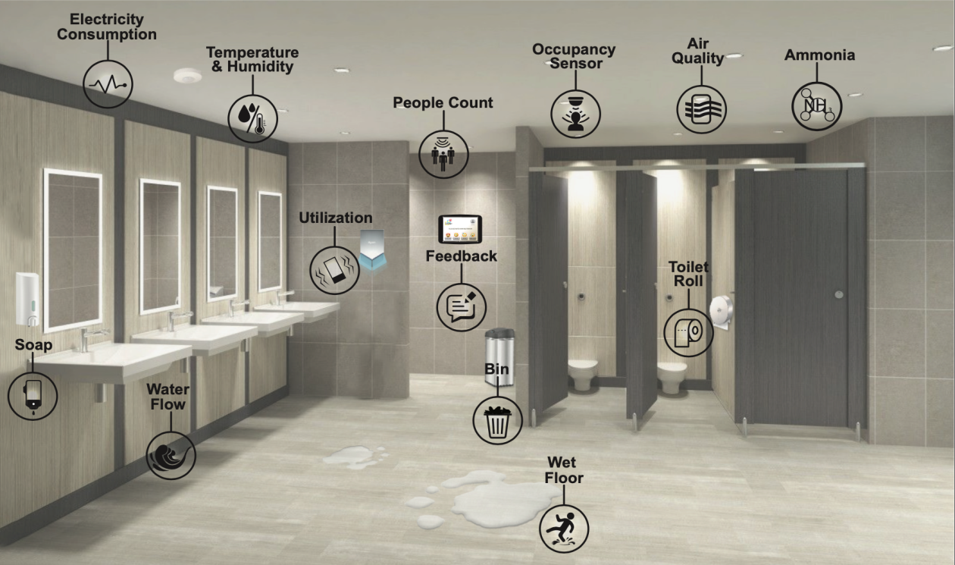

**DESIGN THINKING AND PRESENT IN FORM OF DOCUMENT**

Design thinking is a problem-solving and innovation approach that focuses on understanding the needs of the end-users and creating human-centred solutions. It is often used in product and service design, as well as addressing complex challenges. Design thinking typically involves several iterative stages:

1. Empathize:

This stage involves understanding and empathizing with the people you're designing for. This includes conducting user research, interviews, and observations to gain a deep understanding of their needs, pain points, and behaviours.

1. Define:

In this stage, you define the problem or challenge you want to solve based on the insights gained in the empathy stage. Clearly articulate the problem and create a "problem statement" that guides the rest of the process.

1. Ideate:

Ideation is a creative process where you brainstorm and generate a wide range of possible solutions to the defined problem. Encourage wild and innovative ideas without judgment, using techniques like brainstorming and mind mapping.

1. Prototype:

Create rough, low-fidelity prototypes of the most promising ideas. These prototypes can be physical or digital representations that allow you to quickly test and visualize concepts. The goal is to get early feedback and iterate on your ideas.

1. Test:

Test your prototypes with actual users to gather feedback and insights. This feedback will help you refine and improve your ideas. Iterate on your designs based on what you learn from testing.

1. Implement:

Once you have refined your solution through testing, you can move to the implementation stage, where you develop the final product, service, or solution. This may involve collaborating with developers, engineers, and other experts to bring your concept to life.

Design thinking is characterized by its iterative nature, and it often involves going back and forth between these stages as you learn more about the problem and the potential solutions. The process encourages collaboration and creativity, and it places a strong emphasis on user-centric design.

Key principles of design thinking include:

- Human-Centred: Focus on the needs, emotions, and behaviours of the end-users.

- Iterative: Continuously refine and improve your solutions based on feedback and insights.

- Collaborative: Work in cross-functional teams to leverage different perspectives and expertise.

- Creative: Encourage creative thinking and the exploration of innovative solutions.

- Prototyping and Testing: Rapidly build and test prototypes to learn and adapt.

- Bias To-ward Action: Avoid analysis paralysis and take tangible steps toward solving the problem.

Design thinking can be applied to a wide range of challenges, from product design to business strategy and social issues. It is a flexible and adaptable approach that promotes innovation and user satisfaction.

**DESIGN INTO INNOVATION**

Incorporating design into the innovation process is crucial for organizations seeking to leverage data-driven insights to drive innovation. Here are steps that combine data collection and dataset pre-processing with the broader innovation process:

**1. Define the Innovation Objective:**

- Start by clearly defining the innovation objective and the problem you aim to solve or the opportunity you want to explore. Ensure that the objective aligns with the organization's strategic goals.

**2. Identify Data Needs:**

- Determine the types of data required to address the innovation challenge. This might include customer data, market data, sensor data, or any relevant data sources.

**3. Data Collection Planning:**

- Develop a data collection plan that outlines how and where you will collect data. This includes specifying data sources, data collection methods, and data storage.

**4. Data Collection:**

- Implement the data collection plan by gathering data from relevant sources. Ensure that the data is collected accurately and ethically, and consider privacy and security concerns.

**5. Data Quality Assurance:**

- Perform data quality checks to ensure the collected data is accurate, complete, and consistent. This may involve data cleaning, duplicate removal, and addressing missing values.

**6. Data Pre-processing:**

- Clean and pre-process the collected data to make it suitable for analysis. This includes data transformation, normalization, and feature engineering.

Let's assume you have a CSV file containing restroom usage data with the following columns: `Timestamp`, **`User ID**`, `**Restroom ID**`, `Action` (enter or exit).

**PYTHON PROGRAM**

import pandas as pd

# Load the dataset (replace 'your_dataset.csv' with your actual dataset)

data = pd.read_csv('your_dataset.csv')

# 1. Data Cleaning and Quality Assurance

# Remove duplicates

data = data.drop_duplicates()

# Handle missing values (if any)

data = data.dropna()

# 2. Data Preprocessing

# Convert 'Timestamp' to datetime

data['Timestamp'] = pd.to_datetime(data['Timestamp'])

# Sort the data by 'Timestamp'

data = data.sort_values(by='Timestamp')

# Encode categorical variables (e.g., 'Action') using one-hot encoding

data = pd.get_dummies(data, columns=['Action'], prefix='Action')

# 3. Feature Engineering (if needed)

# Calculate the duration of restroom visits

data['Duration'] = data.groupby('User_ID')['Timestamp'].diff()

# Fill any missing 'Duration' values

data['Duration'] = data['Duration'].fillna(pd.Timedelta(seconds=0))

# Output the preprocessed data

data.to_csv('preprocessed_data.csv', index=False)

# Display the preprocessed data (for illustration)

print(data.head())

**Output:**

Timestamp User ID Restroom ID Action enter Action exit Duration

0 2023-11-01 08:00:00 1 1 1 0 0 days 00:00:00

1 2023-11-01 08:05:00 2 1 1 0 0 days 00:00:00

2 2023-11-01 08:10:00 1 1 0 1 0 days 00:05:00

3 2023-11-01 08:15:00 2 1 0 1 0 days 00:05:00

4 2023-11-01 08:20:00 1 1 1 0 0 days 00:05:00

This program loads a hypothetical dataset, cleans it by removing duplicates and handling missing values, pre-processes the data by converting the timestamp, and performs one-hot encoding on the 'Action' column. It also calculates the duration of restroom visits and fills any missing values. The pre-processed data is then saved to a new CSV file ('preprocessed_data.csv') and displayed for illustration.

Please replace `'your_dataset.csv'` with your actual data file, and adapt the pre-processing steps to your specific data and use case.

**7. Data Integration:**

- If your innovation challenge requires data from multiple sources, integrate the data into a unified dataset for analysis. Ensure that the data is compatible and that you have a clear data integration strategy.

**8. Exploratory Data Analysis (EDA):**

- Conduct EDA to gain insights from the dataset. Visualization and statistical analysis can help identify patterns, trends, and potential relationships in the data.

**9. Hypothesis Generation:**

- Based on the insights from EDA, formulate hypotheses or ideas for potential innovations. These hypotheses should be data-driven and aligned with the defined objective.

**10. Model and Analysis:**

- Utilize data analytics, machine learning, or statistical model to test the formulated hypotheses and generate insights. This may involve predictive model or clustering to uncover patterns.

**11. Iterative Feedback Loop:**

- Continuously iterate between data analysis, pre-processing, and innovation ideation based on the insights gained from the data. This feedback loop ensures that the innovation process remains data-driven.

**12. Prototyping and Testing:**

- Develop prototypes or proofs of concept based on the innovative ideas derived from the data analysis. Test these prototypes with real users or in controlled environments.

**13. User Feedback Integration:**

- Collect user feedback during testing and use it to refine the prototypes. Make data-informed improvements to enhance the user experience.

**14. Business and Technical Feasibility Assessment:**

- Evaluate the feasibility of the innovative solutions from both a technical and business perspective. Consider factors like cost, scalability, and alignment with the organization's capabilities.

**15. Implementation Planning:**

- Create a plan for implementing the selected innovation, which may include resource allocation, timelines, and risk assessment.

**16. Scaling and Deployment:**

- If the innovation proves successful, scale it up and deploy it for wider use or integration within the organization.

**17. Monitoring and Continuous Improvement:**

- Continuously monitor the performance of the innovation and gather data-driven insights for on-going improvement and optimization.

**18. Knowledge Sharing and Documentation:**

- Document the entire innovation process, including data collection and analysis, to share knowledge and best practices within the organization.

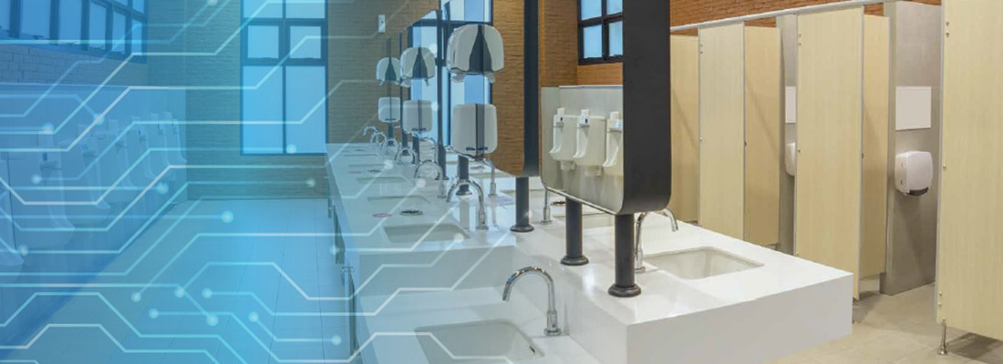

**BUILD LOADING AND PREPROCESSING THE DATASET**

Loading and pre-processing a dataset is a fundamental step in any data analysis or machine learning project. Here are the steps to load and pre-process a dataset using Python:

**1. Import Libraries:**

Start by importing the necessary Python libraries, typically NUMPY and pandas for data manipulation and analysis. Additionally, import any other libraries that may be required for specific pre-processing tasks.

```PYTHON

import numpy as np

import pandas as pd

```

**2. Load the Dataset:**

Load the dataset from a file, database, or other data sources. In this example, we'll use a CSV file as an example. Replace `'your_dataset.csv'` with the actual file path.

```PYTHON

data = pd.read_csv('your_dataset.csv')

```

**3. Exploratory Data Analysis (EDA):**

Before pre-processing, it's a good practice to perform some initial exploratory data analysis to understand the dataset's characteristics. This may include:

- Display basic statistics: `data.describe()`

- View the first few rows: `data.head()`

- Check for missing values: `data.isnull().sum()`

- Visualize data distributions: Matplotlib or Seaborn can be used for plotting.

**4. Data Cleaning:**

Data cleaning involves handling missing values, duplicates, and outliers. Common data cleaning tasks include:

- Removing duplicates: `data = data.drop_duplicates()`

- Handling missing values: `data = data.dropna()`

- Removing or transforming outliers as necessary.

**5. Data Transformation:**

Perform data transformations to make the dataset more suitable for analysis. This may include:

- Encoding categorical variables: One-hot encoding or label encoding for categorical data.

- Scaling numerical features: Standardization or normalization.

- Feature engineering: Creating new features based on existing ones.

**6. Data splitting (if applicable):**

For machine learning tasks, you may need to split the dataset into training and testing sets. Scikit-learn's `train_test_split` function can be used for this purpose.

```PYTHON

from sklearn.model_selection import train_test_split

X_train, X_test, y_train, y_test = train_test_split(X, y, test_size=0.2, random_state=42)

```

**7. Data Pre-processing for Machine Learning:**

If you're working on a machine learning project, you may need additional pre-processing steps such as:

- Handling class imbalances.

- Dimensionality reduction (e.g., PCA).

- Scaling and standardization specific to the machine learning algorithm you're using.

**8. Save Pre-processed Data (if necessary):**

You can save the pre-processed data to a new CSV file for future use.

```PYTHON

data.to_csv('preprocessed_data.csv', index=False)

```

**9. Final EDA and Visualization:**

After pre-processing, it's a good practice to perform another round of exploratory data analysis to ensure that the dataset is clean and ready for analysis.

These steps provide a general framework for loading and pre-processing a dataset. Depending on your specific dataset and project, you may need to adapt and expand on these steps to address unique data challenges and requirements.

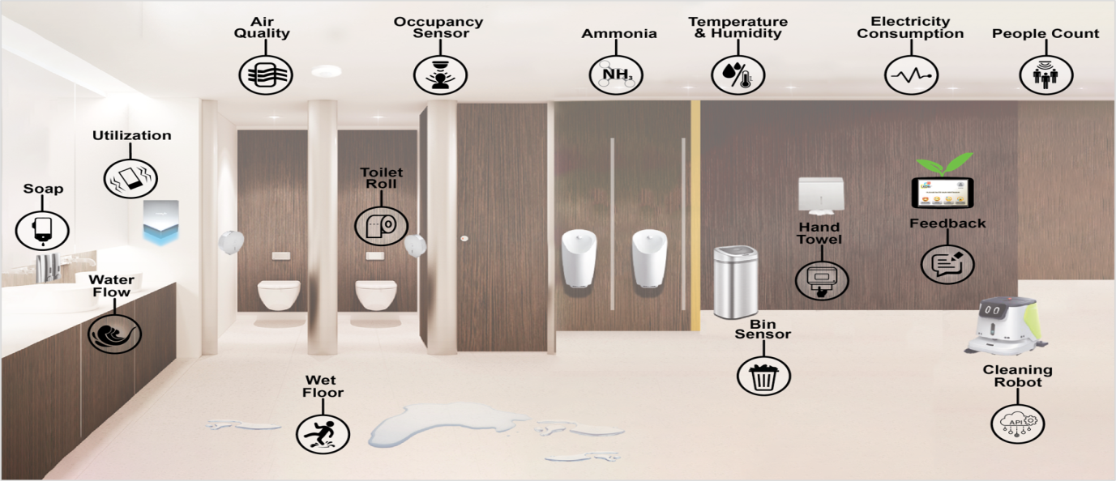

**PERFORMING DIFFERENT ACTIVITIES LIKE FEATURE ENGINEERING, MODEL TRAINING, EVALUATION, etc.**

Certainly, let's expand on the steps for performing different activities like feature engineering, model training, evaluation, and more within the context of a machine learning project. These steps assume you've already loaded and pre-processed your dataset:

**1. Feature Engineering:**

- Create new features from existing ones that may improve the model's predictive power.

- Examples of feature engineering include creating interaction terms, polynomial features, or extracting relevant information from date-time features.

- Scikit-learn provides tools like `PolynomialFeatures` for creating polynomial features.

```PYTHON

from sklearn.preprocessing import PolynomialFeatures

poly = PolynomialFeatures(degree=2)

X_train_poly = poly.fit_transform(X_train)

```

**2. Select Features (if needed):**

- You may want to select a subset of features that are most relevant to your model.

- Techniques like feature selection or dimensionality reduction (e.g., PCA) can be used.

```PYTHON

from sklearn.feature_selection import SelectKBest

selector = SelectKBest(k=10)

X_train_selected = selector.fit_transform(X_train, y_train)

```

**3. Model Selection and Training:**

- Choose an appropriate machine learning algorithm for your problem.

- Split your dataset into training and testing sets (if you haven't already).

```PYTHON

from sklearn.ensemble import RandomForestClassifier

model = RandomForestClassifier()

model.fit(X_train, y_train)

**4. Hyper-parameter Tuning (optional):**

- Tune the hyper-parameters of your model to optimize its performance.

- Techniques like grid search or random search can be used to find the best hyper-parameters.

```PYTHON

from sklearn.model_selection import GridSearchCV

param_grid = {'n_estimators': [100, 200, 300], 'max_depth': [5, 10, 20]}

grid_search = GridSearchCV(model, param_grid, cv=5)

grid_search.fit(X_train, y_train)

best_model = grid_search.best_estimator_

```

**5. Model Evaluation:**

- Evaluate the model's performance using appropriate metrics (e.g., accuracy, precision, recall, F1-score, ROC-AUC) on the test data.

```PYTHON

from sklearn.metrics import accuracy_score, classification_report, confusion_matrix

y_pred = best_model.predict(X_test)

accuracy = accuracy_score(y_test, y_pred)

print("Accuracy:", accuracy)

print(classification_report(y_test, y_pred))

print("Confusion Matrix:\n", confusion_matrix(y_test, y_pred))

```

**6. Model Deployment (if applicable):**

- If your model is ready for deployment, implement it in a production environment.

- This may involve creating APIs, deploying models on cloud platforms, or integrating them into your application.

**7. Monitoring and Maintenance:**

- Continuously monitor your deployed model's performance and retrain it as necessary to keep it accurate.

**8. Documentation:**

- Maintain thorough documentation of your work, including pre-processing steps, model choices, hyper-parameters, and evaluation results.

These steps outline the key activities involved in a typical machine learning project. Keep in mind that machine learning projects often involve iteration and fine-tuning of models and pre-processing steps based on the results obtained during the evaluation stage. It's an on-going process to create and maintain effective machine learning models.

**FEATURE SELECTION**

Feature selection is the process of choosing a subset of relevant features (variables or columns) from your dataset to use in model training. It's an important step in machine learning and data analysis because it can improve model performance, reduce over-fitting, and make models more interpretable. Here are some common techniques for feature selection:

**1. Correlation-Based Feature Selection:**

- Calculate the correlation between each feature and the target variable (e.g., using Pearson correlation coefficient).

- Select the features with the highest absolute correlation values.

- This technique is suitable for regression and classification problems.

**2. Univariate Feature Selection:**

- Select features based on univariate statistical tests, such as chi-squared for classification and F-statistic for regression.

- Scikit-learn provides functions like `SelectKBest` and `SelectPercentile` for this purpose.

```PYTHON

from sklearn.feature_selection import SelectKBest, chi2

selector = SelectKBest(score_func=chi2, k=5)

X_new = selector.fit_transform(X, y)

```

**3. Recursive Feature Elimination (RFE):**

- Recursively training the model and eliminate the least important feature(s) at each step.

- RFE is often used with models that provide feature importance scores, such as tree-based models.

```PYTHON

from sklearn.feature_selection import RFE

from sklearn.ensemble import RandomForestClassifier

model = RandomForestClassifier()

rfe = RFE(model, 5) # Select the top 5 features

X_rfe = rfe.fit_transform(X, y)

```

**4. L1 Regularization (Lasso):**

- Use L1 regularization to encourage some feature coefficients to become exactly zero, effectively performing feature selection.

- This is particularly useful when dealing with high-dimensional datasets.

```PYTHON

from sklearn.linear_model import Lasso

model = Lasso(alpha=0.01)

model.fit(X, y)

selected_features = X.columns[model.coef_ != 0]

```

**5. Tree-Based Feature Selection:**

- Decision tree-based models, such as Random Forest or XGBoost, can provide feature importance.

- You can select features based on their importance scores.

``PYTHON

from sklearn.ensemble import RandomForestClassifier

model = RandomForestClassifier()

model.fit(X, y)

feature_importances = model.feature_importances_

selected_features = X.columns[feature_importances > threshold]

```

**6. Mutual Information:**

- Mutual information measures the dependency between variables. It can be used to estimate feature relevance.

- Scikit-learn's `SelectKBest` with `mutual_info_classif` or `mutual_info_regression` can be used for this purpose.

```PYTHON

from sklearn.feature_selection import SelectKBest, mutual_info_classif

selector = SelectKBest(score_func=mutual_info_classif, k=5)

X_new = selector.fit_transform(X, y)

```

**7. Sequential Feature Selection:**

- Sequential feature selection methods, such as Sequential Forward Selection (SFS) and Sequential Backward Selection (SBS), iteratively add or remove features based on their impact on model performance.

Feature selection should be performed based on the specific problem and dataset. It's important to evaluate the selected features' impact on the model's performance through cross-validation or other evaluation techniques. Additionally, consider the interpretability of the model when selecting features, as more interpretable models are often preferred in practice.

**ADVANTAGES:**

Implementing smart public restrooms using the Internet of Things (IOT) offers several advantages that can enhance user experience, improve resource management, and contribute to overall efficiency. Some of the key advantages include:

**1. Enhanced User Experience:**

- Smart restrooms can provide a more convenient and comfortable experience for users. For example, automated toilet flushing, touch-less faucets and soap dispensers, and occupancy monitoring can reduce the need for physical contact with surfaces, enhancing hygiene.

**2. Improved Hygiene and Sanitation:**

- IOT devices can enable real-time monitoring and alert systems for restroom cleanliness and supply levels. Maintenance staff can be alerted when cleaning is needed, and supply levels for soap, paper towels, and toilet paper can be monitored, reducing the chances of running out.

**3. Energy and Water Efficiency:**

- IOT sensors can be used to optimize energy and water consumption. For instance, lighting and HVAC systems can be automatically adjusted based on occupancy, reducing energy waste. Smart fixtures can control water flow and reduce consumption.

**4. Predictive Maintenance:**

- IOT sensors can monitor the condition of restroom facilities, such as toilets, faucets, and hand dryers. Predictive maintenance can help prevent breakdowns by identifying issues early, reducing downtime, and saving on maintenance costs.

**5. Real-Time Monitoring:**

- Facility managers and staff can monitor the status of restrooms in real-time through IOT dashboards and receive alerts when issues arise. This enables rapid response to problems and ensures a consistently clean and functional environment.

**6. Reduced Labour Costs:**

- Automation and real-time monitoring can reduce the need for manual checks and maintenance, leading to cost savings by optimizing labour resources.

**7. Data-Driven Insights:**

- IOT devices can collect data on restroom usage, which can be used to analyse traffic patterns, peak usage times, and user behaviour. This data can inform decisions about resource allocation, cleaning schedules, and facility design.

**8. Accessibility and Inclusivity:**

- Smart restrooms can be designed to be more accessible and inclusive for individuals with disabilities. IOT sensors can help make facilities adaptable to the specific needs of users, such as automatic door openers and accessible washroom stalls.

**9. Sustainability and Environmental Impact:**

- The ability to monitor and reduce resource consumption, such as water and energy, contributes to a more environmentally friendly operation. Reduced waste and more efficient resource utilization support sustainability goals.

**10.User Feedback and Satisfaction:**

- Some IOT systems include user feedback mechanisms, such as mobile apps or touchscreens, where users can report issues or provide feedback. This can improve user satisfaction and the overall quality of service.

**11. Security and Safety:**

- IOT devices can enhance the security and safety of public restrooms. For example, surveillance cameras and access control systems can help deter criminal activities and ensure the safety of users.

**12. Smart Advertising and Marketing:**

- Smart restrooms can provide opportunities for targeted advertising and marketing by displaying promotions or messages based on user demographics or behaviour.

**13. Compliance and Reporting:**

- IOT systems can assist in monitoring compliance with regulations and standards related to public restrooms, ensuring that they meet legal and accessibility requirements.

Overall, smart public restrooms using IOT technology can create a more efficient, hygienic, and user-friendly environment while optimizing resource usage and reducing operational costs. These advantages make them a valuable addition to various public spaces, such as airports, shopping malls, stadiums, and transportation hubs.

**DISADVANTAGES:**

While smart public restrooms using IOT offer several advantages, they also come with certain disadvantages and challenges. Some of the common disadvantages include:

1. **Cost:**

Implementing IOT in public restrooms can be expensive. It involves the installation of various sensors, network infrastructure, and maintenance costs. This cost can be a significant barrier, particularly for smaller facilities or organizations with limited budgets.

1. **Complexity:**

IOT systems can be complex to set up and manage. They involve multiple components like sensors, gateways, cloud services, and mobile apps, which require technical expertise to integrate and maintain. Complex systems can lead to technical issues and downtime.

1. **Privacy Concerns:**

IOT sensors in restrooms can collect sensitive data, such as occupancy patterns or usage frequency. Privacy concerns may arise if users are uncomfortable with their data being collected and analysed, even if it's for improving services.

1. **Security Risks:**

IOT devices are vulnerable to cyber-attacks. Insecure IOT devices can be exploited to gain access to networks or collect sensitive data. Ensuring the security of the IOT system is crucial to prevent unauthorized access and data breaches.

1. **Maintenance and Reliability:**

IOT devices, like any technology, require regular maintenance and updates. If not properly maintained, devices may malfunction, leading to unreliable restroom services. Additionally, network connectivity issues may affect the reliability of the system.

1. **User Adoption:**

Some users may find the idea of smart restrooms and IOT technology in public spaces uncomfortable or unfamiliar. Encouraging users to embrace and use these facilities may require education and outreach efforts.

1. **Technical Issues:**

IOT devices can experience technical issues, such as sensor malfunctions or communication problems. These issues can disrupt restroom operations and require timely troubleshooting and maintenance.

1. **Environmental Concerns:**

The production and disposal of electronic IOT devices can have environmental implications. Ensuring responsible manufacturing and disposal practices is essential to mitigate these concerns.

**9. Power Consumption:**

IOT devices typically require a power source, which can be a concern in remote or outdoor restroom facilities where access to electrical outlets may be limited. Battery-powered devices may require frequent replacement.

**10. Interoperability Challenges:**

IOT systems from different manufacturers may not always be compatible, leading to interoperability challenges. Ensuring that all components work seamlessly together can be a complex task.

**11. Data Overload:**

Collecting vast amounts of data from IOT devices can lead to data overload. Analysing and deriving valuable insights from this data can be a challenge without appropriate data management and analytics tools.

**12. Legal and Regulatory Compliance:**

Compliance with data protection laws and regulations (e.g., GDPR, HIPAA) can be challenging, especially if the restroom system collects and stores personal information.

To mitigate these disadvantages and ensure the successful implementation of smart public restrooms using IOT, organizations should conduct thorough planning, prioritize user privacy and security, and invest in on-going maintenance and system monitoring. Additionally, clear communication with users about the benefits and data handling practices can help build trust and encourage adoption.

**BENEFITS:**

Smart public restrooms that use the Internet of Things (IOT) technology offer several benefits, both to the public and facility operators. Here are some of the key advantages:

**1. Improved Hygiene and Sanitation:**

- Automatic flush toilet, touch-less faucets, and soap dispensers reduce the need for physical contact with restroom fixtures, improving hygiene and reducing the risk of the spread of germs and diseases.

**2. Efficient Resource Management:**

- IOT sensors can monitor restroom occupancy, allowing facility operators to optimize cleaning schedules and resource allocation, saving water, energy, and maintenance costs.

**3. Enhanced User Experience:**

- Smart restrooms can provide real-time information about restroom availability and cleanliness to users, reducing wait times and improving the overall experience.

**4. Energy and Water Savings:**

- IOT sensors can monitor water and energy usage in restrooms, enabling the identification of inefficiencies and opportunities for conservation.

**5. Predictive Maintenance:**

- Sensors can detect issues such as leaks or equipment malfunctions in real time, allowing for predictive maintenance. This reduces downtime and ensures that facilities remain in good working condition.

**6. Sustainability and Green Initiatives:**

- Smart public restrooms can support environmental sustainability goals by reducing water waste, energy consumption, and the use of paper towels through efficient hand dryers.

**7. Cost Savings:**

- By automating processes and optimizing resource management, smart restrooms can lead to cost savings for facility operators in terms of water, energy, labour, and maintenance.

**8. Real-Time Data Insights:**

- IOT technology provides facility managers with real-time data on restroom usage, occupancy patterns, and equipment status, enabling data-driven decision-making.

**9. Accessibility and Inclusivity:**

- Smart restrooms can be equipped with features such as occupancy and usage alerts for people with disabilities, making public facilities more inclusive.

**10. Remote Monitoring and Control:**

- Facility operators can remotely monitor and control restroom functions, such as adjusting temperature, lighting, or water flow, improving user comfort and energy efficiency.

**11. Data-Driven Insights for Planning:**

- Collected data can be used to analyse restroom usage patterns, helping planners and designers create more efficient and user-friendly public restrooms in the future.

**12. User Feedback and Satisfaction:**

- Smart restrooms can collect user feedback through mobile apps or sensors, helping facility operators address issues and improve user satisfaction.

**13. Compliance and Safety:**

- IOT technology can help ensure compliance with regulations and safety standards by monitoring conditions such as air quality and ADA (Americans with Disabilities Act) compliance.

**14. Emergency Response:**

- In the event of an emergency or security issue, smart restrooms can provide real-time data to aid emergency response teams.

**15. Customization and Personalization:**

- Some smart restroom systems can offer customizable experiences, such as adjusting lighting and music preferences, enhancing user comfort.

These benefits contribute to a more convenient, sustainable, and hygienic public restroom experience while also helping facility operators save resources and improve operational efficiency. The adoption of IOT technology in public restrooms is a step toward more advanced and user-centric public facilities.

**CONCLUTION:**

* In conclusion, the integration of IOT technology in smart public restrooms represents a significant advancement in public facilities management and user experience. Smart public restrooms offer a range of benefits, including enhanced hygiene, resource efficiency, and improved user satisfaction. Through IOT sensors and connectivity, these facilities can monitor and manage various aspects, such as occupancy, cleanliness, water usage, and more, in real time. This data-driven approach allows for efficient maintenance and resource allocation.
* Furthermore, the implementation of IOT technology in public restrooms promotes sustainability by reducing water and energy waste, and it helps in minimizing operational costs. The ability to provide users with real-time information and automated services, such as touch-less fixtures and alerts for maintenance needs, significantly improves the overall restroom experience.
* However, it's important to address privacy and security concerns associated with the collection and transmission of data in smart public restrooms. Proper data protection measures and user awareness are essential to ensure the responsible use of IOT technology in these facilities.
* In summary, smart public restrooms using IOT exemplify how technology can transform and enhance public infrastructure for the benefit of both users and facility managers. As IOT continues to evolve, we can expect even more innovative solutions and improved public amenities in the future.

**…THANK YOU…**